15th October 2015

**YOKOHAMA Advancing Tyre Aerodynamics Technology**

*New advances reduces vehicle aerodynamic drag and lift*

Tokyo –The Yokohama Rubber Co., Ltd., announced today that it has made new advances in tyre aerodynamics technology that control the air flow around tyres in motion. The new development reduces vehicle aerodynamic drag and lift. Application of the new technology could lead to the development of new tyres that will raise fuel efficiency and increase vehicle safety.

Following its successful research on rolling resistance, YOKOHAMA has been focusing its research on aerodynamics technology on the reduction of vehicle air drag, including the use of aerodynamic simulation technology since 2010. In December 2012, YOKOHAMA developed a technology for placing fin-shaped protuberances on the inner sidewall of the tyre in a radial or spoke-like pattern to reduce the aerodynamic drag inside the wheel wells. The latest development seeks to control aerodynamic flow throughout the vehicle body by using a new fin shape and placement technique that places the fin protuberances at angles near the tyre’s shoulder. The fins on the tyre’s outer sidewall help to reduce vehicle aerodynamic drag when on the upper part of the tyre during its rotation while suppressing vehicle aerodynamic lift when on the lower part of the tyre. In addition, we conducted a large-scale parameter study in collaboration with a team led by Professor Shigeru Obayashi of Institute of Fluid Science, Tohoku University; this study used a Supercomputer “K” to run aerodynamic simulations at different parameter values to determine the impact of changes in the parameter values on a desired result. This study led to new knowledge about the optimal placement of fins on the tyre surface in order to enhance tyre aerodynamics.

To date, YOKOHAMA’s research on aerodynamics technology has to a number of new tyre designs that contribute to vehicle fuel efficiency, including a dimple design that places small depressions on the side of the tyre and the aforementioned fin tyres, with fins located on the side of the tyre. The latest breakthrough will enable more optimal placement and shaping of dimples and fins as YOKOHAMA accelerates its research of tyre designs that not only improve tyres’ fuel performance but also enhance performance in many other areas.

The aerodynamic tyre with new fin pattern will be on display at the YOKOHAMA display at the 44th Tokyo Motor Show 2015, to be held from 28th October at the Tokyo Big Sight in Tokyo, Japan.



*Image of normal tyre (left) and aerodynamic tyre with new fin pattern (right)*

**Aerodynamic flow from normal tyre and aerodynamic tyre with new fin pattern (Analysis based on aerodynamics simulation)**

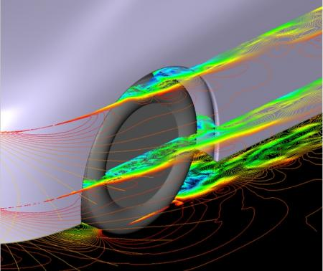

*Image of aerodynamic flow patterns for normal tyre*

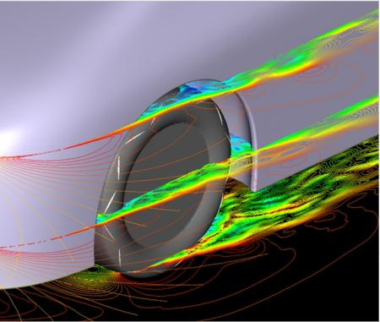

*Image of aerodynamic flow patterns for aerodynamic tyre with new fin pattern*

Aerodynamic flow from the upper part of the aerodynamic tyre with new fin pattern runs along the side of the tyre and car body while flow from the lower part of the tyre spreads out from car body.